Reliant HVAC AI Receptionist
System Documentation

Version 1.0
September, 2025
Contents
Section 1 Introduction 2
1.1 Purpose 2
1.2 Scope 2
Section 2 System Overview 2
2.1 Description 2
Section 3 n8n Workflow Configuration 3
3.1 [Tool] Cal.com Check Availability 3
3.2 [Tool] Cal.com Book Appointment 3
Section 4 Account Credentials 4
Section 5 Conclusion 5

Section 1 Introduction

1.1 Purpose
This documentation outlines the setup and configuration of the Inbound Demo AI Voice Agent System, designed to simulate HVAC customer interactions for demonstration purposes.

1.2 Scope
This section covers the setup, operation, and management of the standalone demo tool, utilizing Retell.ai, n8n, OpenAI, Cal.com, and Twilio, tailored for Heather Warden’s sales presentations.

Section 2 System Overview

2.1 Description
The Inbound Demo AI Voice Agent simulates interactions for a fictional HVAC company (Reliant HVAC), allowing prospects to experience the appointment booking process.

Section 3 n8n Workflow Configuration

3.1 [Tool] Cal.com Check Availability
- Purpose: Queries Cal.com for available appointment slots.
- SOP:
- Log in to n8n dashboard.
- Open "Check Availability" workflow.
- Verify Cal.com API key and Event Type ID (blue sticky note nodes).
- Test via "Execute Workflow" with sample date/time.
- Updates: Change Event Type ID for new calendar events from Cal.com URL.
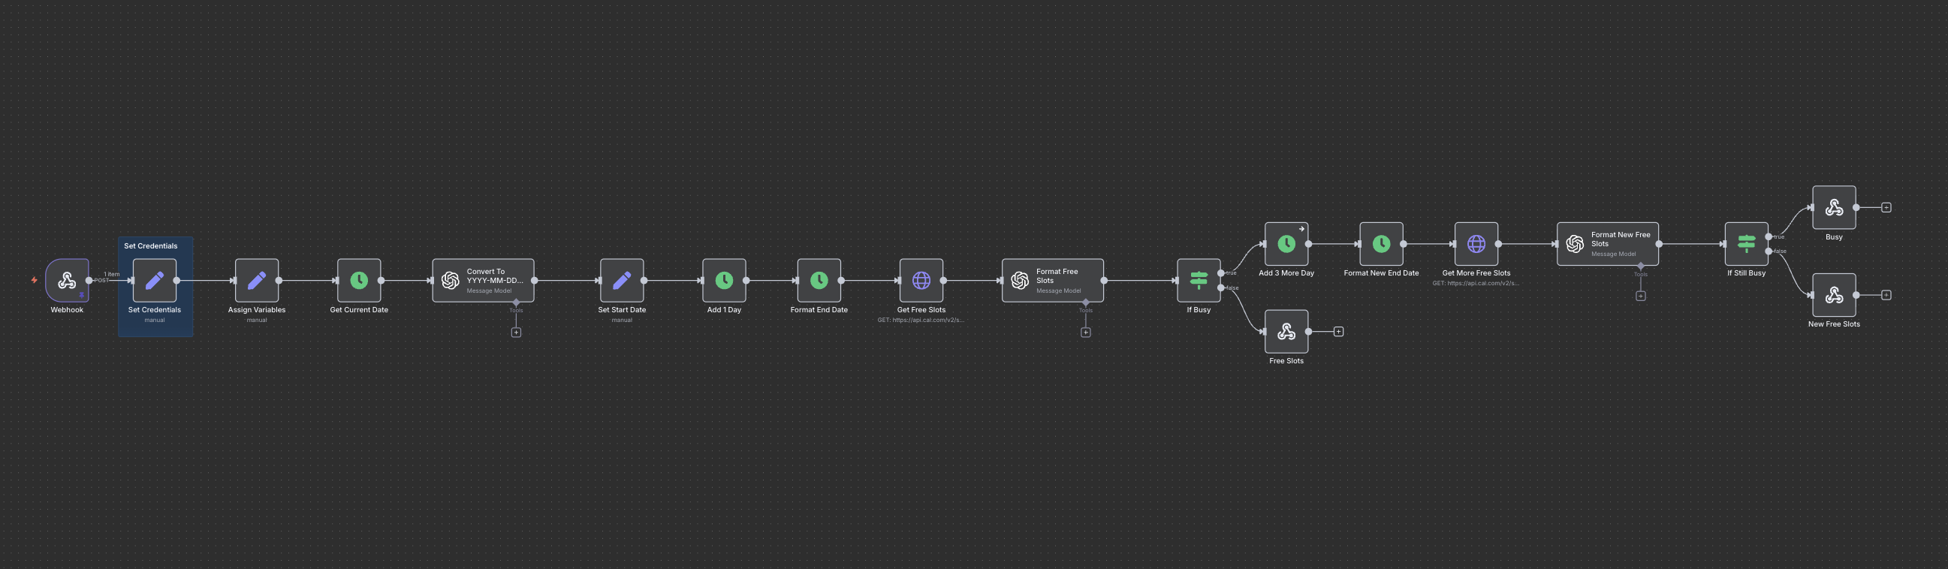

3.2 [Tool] Cal.com Book Appointment
- Purpose: Books simulated appointments via Cal.com API.
- SOP:
- Log in to n8n dashboard.
- Open "Book Appointment" workflow.
- Verify Cal.com API key and Event Type ID (blue sticky note nodes).
- Test with sample caller details.
- Optional: Activate error notification (deactivated by default):
- Add Google credential.
- Set email node with recipient, subject ("Appointment Booking Failed"), and error details.
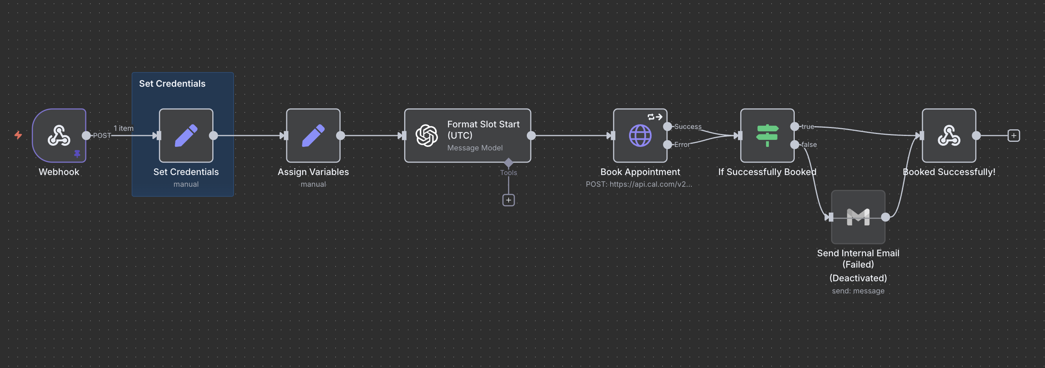

Section 4 Account Credentials
- Retell.ai:
  - Email: Reliantaisystems@gmail.com
  - Password: Fl4R08!N25
- n8n:
  - Email: Reliantaisystems@gmail.com
  - Password: Fl4R08!N25
- Cal.com:
  - Username/Email: Reliantaisystems@gmail.com
  - Password: Fl4R08!N25
  - API Key: cal_live_b85c9a605497467ab7d41f16f9d4f3ab
- Twilio:
  - Username/Email: Reliantaisystems@gmail.com
  - Password: Fl4R08!N25
Note: Store these credentials securely and update passwords regularly. API keys (e.g., Cal.com, OpenAI) are integrated into workflows; retrieve from respective dashboards if needed.

Section 5 Conclusion
This guide equips Heather Warden’s team with the knowledge to independently set up, operate, and manage the Inbound Demo AI Voice Agent.
For additional support, feel free to contact us at hsienjunong@qwickstep.ai.

